PAGBAG-O Member Organizations:
- 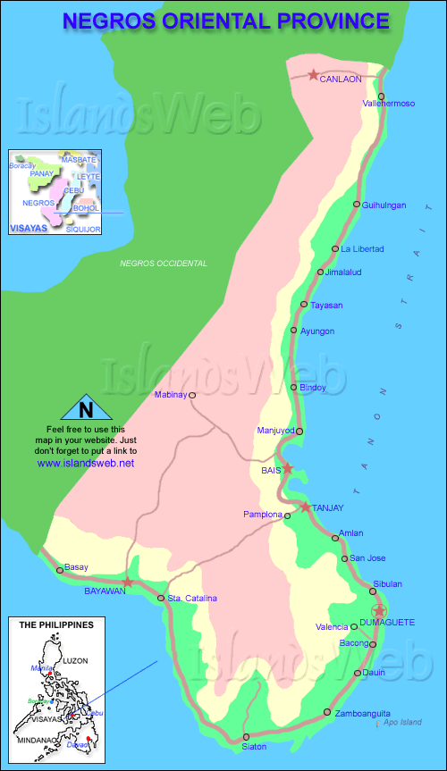Mayaposi Farmers Ass’n. (MAFA)
- Nagwaling Community Farmers Association (NACFA)
- Bahay Malaumon Farmers Association (BMFA)
- Balatong United Christian Farmers Association (BUCFA)
- Community Ajong Multi Purpose Cooperative (CAMPUCO)
- Christian Farmers Association of Samac (CFAS)
- Campu-Aling Mayaposi Farmers Association (CMFA)
- Lig-ong Inahang Kababayen-an Hinugpong sa Anibong (LIKHA)
- Siit Bayanihan Association (SBA)
- Samac United Farmers for AR Multi-Purpose Cooperative (SUFARMPUCO)
- Tubo United Farmers Association (TUFA)
- Calabnugan Small Coconut Farmers Association (CASCOFA)
- Bonbonon Fishermen Association (BFA)
- San Jose Fishermen Association (SJCA)
- Kapunongan sa Aeta ug mga Mag-uuma sa Canggohob (KAMAMACA)
- Kapunongan sa Ata Bukidnon sa Pantao Indigenous People
- Andulay Fishermen Association ( AFA)
- Brgy. Lamogong Farmers Association (BLFA)
- Balaas Small Coconut Farmers Association (BASCOFA)
- San Isedro Coconut Farmers Association (SANICOFA)
- Kapunongan sa mga Mag-uuma sa Nalundan (KASAMANA)
- Kapunongan sa mga Mag-uuma sa Danao (KAMADA)
- Kapinongan sa mga Mag-uuma ug Mangingisda sa Pangalaycayan ( KAGAMMPA)
- Kapunongan sa mga Mag-uuma ug Mananagat sa Inacban (KAMMI)
- Kapunongan sa Gagmayng Mag-uuma sa Tampucon 1
( KAGAMATA)
- Sab-ahan Tribu Bukidnon Association
- Mabunao Farmers Association (MAFLIP)
- Boloc-boloc Farmers Association (BOFAS)
PAGBAG-O Staff:
Executive Director | Jose T. Alatan
Program Coordinator | Evelyn C. Abella
Finance Officer/Bookeeper | Necita Z. Navarro
Cashier | Paulyn O. Estrellado
IB Program Managers | Restituto B. Aranas  Manolito E. Lumayag
SRMDP Program managers | Miguel A. Cabilao  Felixberto P. Trumata
CBED Program Manager | Narditha F Janssen  Jerson Denoy

PAGBAG-O, INC.
LOCATION MAP OF MEMBER ssSORG’s

PAGBAG-O INC.
A people’s federation that fosters active participation, towards the development and improvement of livelihoods and communities within Negros Oriental.

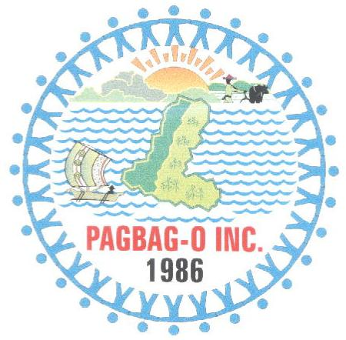

Pleasantville Subdivision

Banilad, Dumaguete City, Philippines 6200

Tel No, (035) 421-2142

E-mail Address: pagbag.o@gmail.com

Website: Pagbag-o.weebly.com

How PAGBAG-O was formed:

The Panaghugpong sa mga Gagmayng Bayanihang Grupo sa Oriental Negros, Inc. or PAGBAG-O is a federation of 28 farmers, fisher folks and IP`s organizations in Negros Oriental.

The province-wide federation was formed to fill the need for a people’s organization that assists the development of people and their communities throughout Negros Oriental.

PAGBAG-O was formed in 1986 during the initial stages of the Indigenous Development Education and Social Assistance (IDESA) program. In 1996 PAGBAG-O registered with the Securities and Exchange Commission (SEC) and acquired legal identity.

In 1998, IDESA operations were phased out by NDC and PAGBAG-O gained autonomy as an organization.

VISION

To work towards a prosperous and harmonious community, with strong faith in God, where justice prevails, and where there is equal opportunity to develop the spiritual, social, cultural, and economic aspects of the lives of its members.

MISSION

To foster active people’s participation in the development process that will lead towards the attainment of the aspirations and the overall welfare of the poor communities.

GOALS

- To contribute to the improved quality of life of men and women small farmers in the rural and upland areas in Negros Oriental who are suffering from increasing poverty and hunger.

PAGBAG-O PROGRAMS & SERVICES:

  - CAPACITY BUILDING PROGRAM (CBP)

This program aims to enhance the effectiveness and sustainability of member organizations through training and educational activities that assist internal organizational development

  - SUSTAINABLE RESOURCE MANAGEMENT AND DEVELOPMENT PROGRAM (SRMDP)

This program aims to enhance the participation of communities in sustainable agriculture activities by improving their productivity and conservation of their natural resources.

  - COMMUNITY-BASED ENTERPRISE DEVELOPMENT PROGRAM (CBEDP)

This program aims to propel the diffusion of vibrant rural economics through the establishment of community enterprises that would uplift the socio-economic conditions of PO members.

Other projects include:
- PAGBAG-O ORGANIC FERTILIZER (POF)
- Natural Coffee (Farmers Pride)
- Honey from IP`s

PAGBAG-O’s development partners:

PAGBAG-O is supported by:
- BftW – PDS
- Feed The Children Philippines (FTCP)
- SMITZ FOUNDATION
PAGBAG-O is a member of:
- CERNET-Community Empowerment and Resource Network
- NEGORNET –Negros Oriental Network of NGOs & Pos
- SIBAT – Sibol ng Agham at Teknologiya.
- PHILCOS
- CODE NGO
- ABSNET- Area Based Network (DSWD)
- CENVISNET- Central Visayas Network

PAGBAG-O works in partnership with the following GA’s:
- DAR / DA / DENR / DOLE / DSWD / NCIP / DILG / LGU`s

PAGBAG-O CONSULTANTS:
- PRISMS
- CTI

